CONCAVE SUMMIT 2021:
‘Shifting Mindsets in Sustainability & Social Impact’

An independent summit exploring the convergence of Sustainability & Social Impact with Technology, through the lens of Culture & Community

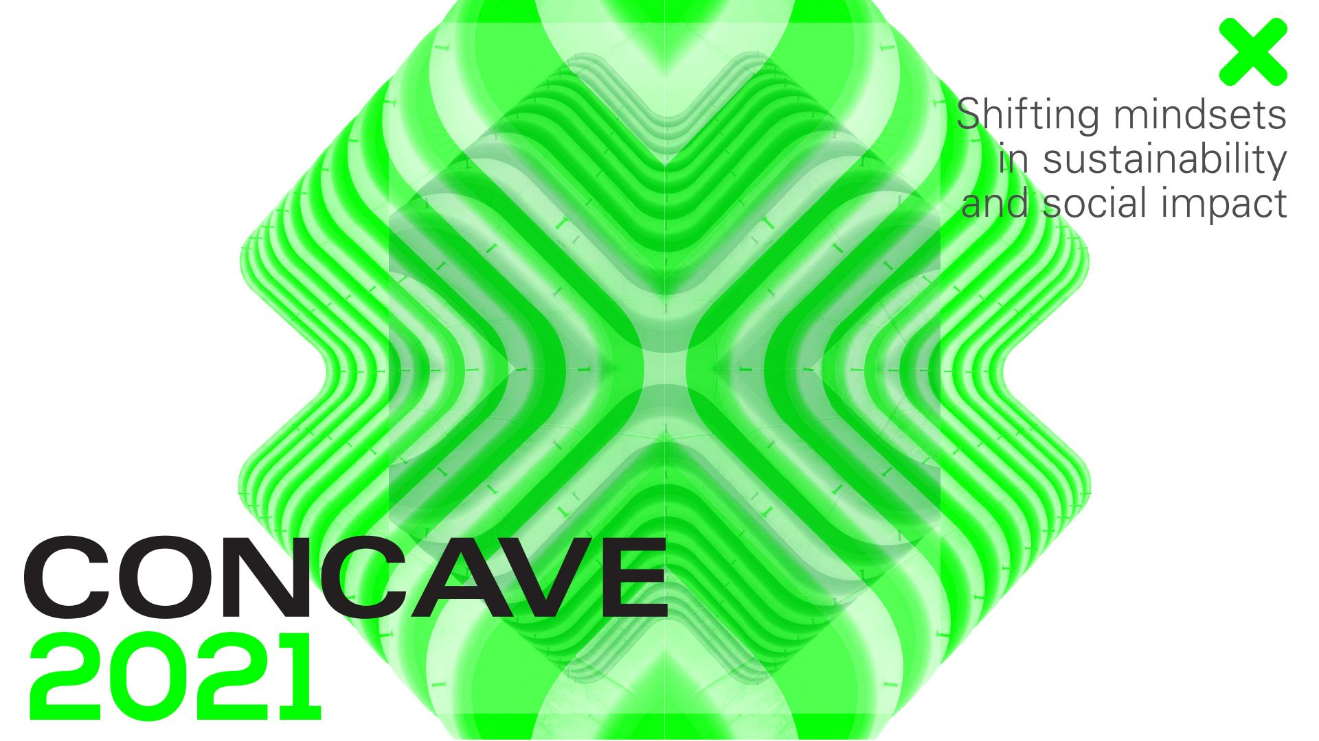

THURSDAY 23RD SEPTEMBER 2021: Concave Summit, is an independent summit exploring the convergence of Sustainability & Social Impact with Technology, through the lens of Culture & Community, and this year debuts its hybrid event in London on Thursday 23rd September. Platforming worldly perspectives from leading and emerging voices in sustainable technology who position culture and community at the heart of what they do, Concave Summit is one of only a few events part of the London Tech Week that focuses on Global Impact.

Drawing from Concave’s networks in Singapore, Southeast Asia, UK & Europe, the theme of Concave Summit 2021 is, ‘Shifting Mindsets in Sustainability & Social Impact’ which will zoom in on the topics of Sustainability; Circular Economy; Diversity & Inclusion; Digital Wellness; Food Tech; Education Tech; and Driving Social Change through Digital Technology, achieved through both live and virtual events. The day's event will be divided into three components: two stages (live and virtual), and a virtual exhibitor booth arena for the summit's global community and partners.

Discussions and sessions make up the day’s program, starting off with a keynote appearance from Tom Tapper, co-founder and CEO of B Corp creative agency Nice and Serious. Tapper aims to explore the role businesses play in our society, and why putting profit above purpose has created many of the crises we now see in the world. He'll share the story of how his agency lost its way, before codifying a moral compass into the decision-making process. He'll discuss the importance of bringing humanity back into business, and how it can benefit us all.

(L-R: Tom Tapper, Dr Anna Sulan Masing, Chloe-Rose Crabtree, Katee Hui, Zoë Gibson Quirk, Benedict Macon-Cooney, Alexander Losad)

Plus appearances from founders of Sourced Journeys, Dr. Anna Sulan Masing and Chloe-Rose Crabtree, the latter of which will pose ‘How can tech be developed to service the needs of local communities?’. Katee Hui (Pentagram, and founder of Hackney Laces) and Zoë Gibson Quirk (ZoandCo) will address the Gender Equality Gap.

The day’s program line-up will also feature panel sessions presented by the Tony Blair Institute for Global Change hosted by Benedict Macon-Cooney, Deputy Executive Director for Tech Policy who will discuss the best approach for policymakers to stay on track with food tech innovations and obstacles to be addressed from R&D funding to regulations. Also joined by Alexander Losad, Policy Lead for Digital Government Unit who will discuss the rapidly-changing role of education and the dire need for a systems-level evolution in global and national policy to enable new-tech inclusive education practises to be trailed and scaled up.

After the event, the conversations will continue via the platform hub, Swapcard to help build and foster growth of the network throughout the year.

WHY CONCAVE?

The beauty of Concave is the intimate size and interdisciplinary network, which encourages real and strong connections between the audience and the voices platformed. Since its original launch in Singapore, 2018 as part of a larger tech conference, and its UK debut in London at Ace Hotel Shoreditch, 2019, Concave has become a space for open discussion that amplifies social good, accelerates positive change and most importantly, has built a socially-conscious community.

Undergoing a few iterations since its inception in 2018, which founder, Vicki Yeo, launched as an experiment after being inspired by SXSW’s focus on Culture (then defined as Music, Film, Art, Design, Civil Society and Social Impact) intersecting with Technology. Vicki and her network grew organically to focus on Sustainability, Social Impact & Creative Entrepreneurship, with efforts towards the Culture mission in 2019.

Fast forward to 2021 as Concave works towards establishing this new summit brand, various divisions shall also branch out in near future as separate activations focused on driving positive change across different aspects - Concave CultureTech // Concave NextGen // Concave Coalition // Concave Impact.

Taking place throughout London Tech Week (20th – 24th September), registration for the summit is now open - see here for registration details. For more information on the full line-up, sessions and keynote appearances, please visit the website.

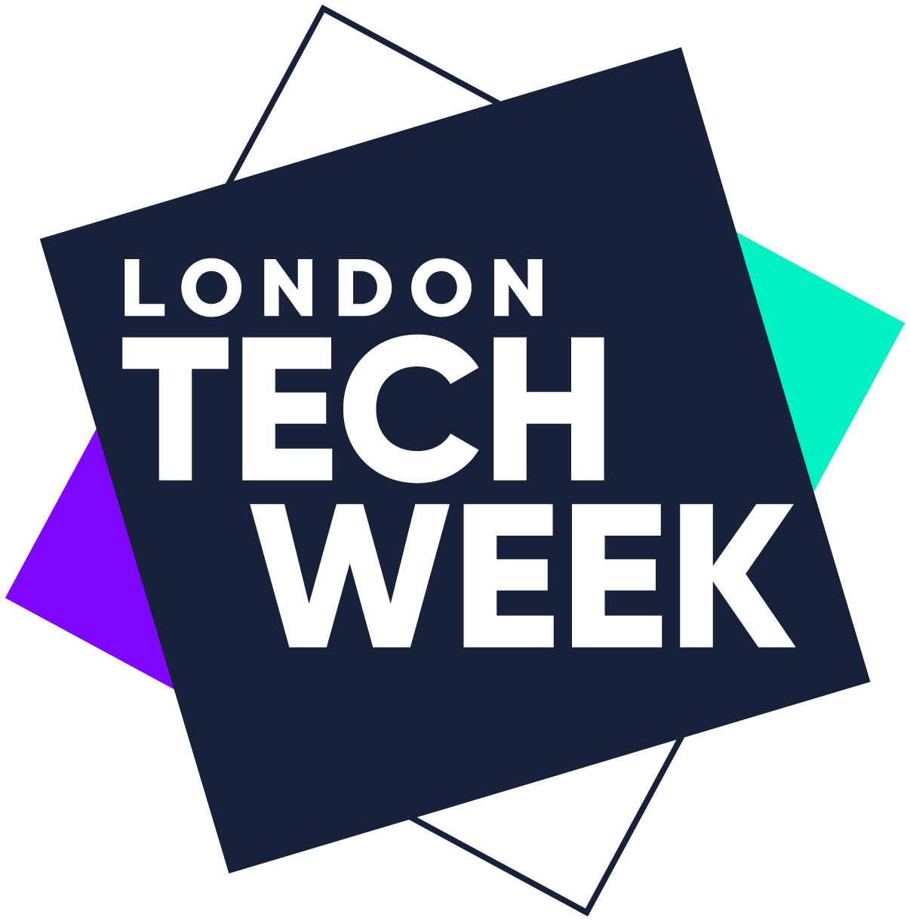

All speakers are available for interview. Please get in touch with Frankie for info and any other press enquiries: frankie@anna-frankie.com. Press images to support the press release can be found here.

Concave Summit 2021 Registration:
https://concavesummit2021.eventbrite.co.uk

Concave is a purpose-led & solutions-driven summit. We all have it within us to amplify social good and accelerate positive change. Join Concave Summit virtually for their first hybrid event and network with a socially conscious community.

www.concavesummit.com
@concavesummit | @ConcaveSummit | Facebook

-END-

For all media enquiries, interview opportunities, please contact Frankie Reddin: frankie@anna-frankie.com

Notes to Editors

Concave Summit
We all have it within us to amplify social good and accelerate positive change. Join us virtually for our first hybrid event and network with a socially conscious community. Concave Summit is a purpose-led & solutions-driven conference. We are focused on building a socially-conscious coalition to drive positive change. In 2018, we debuted in Singapore and successfully matched a satellite mapping technology partner to an organisation saving Asian elephants with conservation technology - by having the right people in the right room. We bring together business leaders and creative founders who care about culture, sustainability, social impact and technology.

Concave Summit 2021 will explore the convergence of Sustainability and Social Impact with technology, through the lens of Culture & Community. Our key theme is SHIFTING MINDSETS - across our tracks in food sustainability; food tech; the circular economy; digital wellness; education tech; diversity and inclusion; driving social change through digital technology - to name a few.

Mentioned speakers bios can be viewed here and include:
Tom Tapper, Dr. Anna Sulan Masing, Chloe-Rose Crabtree, Katee Hui, Zoë Gibson Quirk, Benedict Macon-Cooney, Alexander Losad

CONCAVE OVERVIEW:

Thurs 23 Sept, 8:30am - 5pm
White City House Studios
Breakfast bites, lunch and drinks provided

Throughout Concave
The Main Stage can be attended in-person, watched online and/or watched after the event has taken place
The Booths will be digital ‘rooms’ where brands can showcase their brand mission and chat to summit attendees (on the day). These brands are likely to have been part of the panels. Post the live event, those that have registered can still access the Booths and message the brands - akin to a social media platform

Panel sessions presented by Tony Blair Institute for Global Change
Keeping up with Foodtech: Are Policymakers on Track?
Hosted by Benedict Macon-Cooney, Deputy Executive Director for Tech Policy, Tony Blair Institute
Innovations across the food chain, from agriculture to cultured meat, are giving us an exciting glimpse of a future where feeding the world doesn’t come at the expense of the environment. However, tackling food security and sustainability must come from both the private and public sectors, as the step from creation to adoption is vast. Policymakers are needed to address obstacles such as R&D funding, training, investment in manufacturing capabilities, and regulation. How should policymakers approach this? What does the private sector need to know?

Are We Ready for Tech-Inclusive Education?
Hosted by Alexander Losad, Policy Lead, Digital Government Unit, Tony Blair Institute
Demand for education is increasing exponentially, and its role and purpose are changing rapidly. But access to high-quality education is uneven. To solve this problem, a systems-level evolution in global and national policy is needed to allow new tech-inclusive practices to be trialled and scaled up.

Other Virtual Arena Curators
TV Presenter of Edible Wild (Channel News Asia), Nithiya Laila https://admin.channelnewsasia.com/watch/edible-wild - Founder of @brunchbandits65 and advocate for food nutrition sustainability & biodiversity in the global south
Reuse Lab https://www.thereuselab.com - A design research laboratory that innovates for social impact and advocates for circular systems to reduce single use plastics
Morning https://www.drinkmorning.com - A coffee-tech company that disrupted the coffee capsule landscape by offering recyclable and compostable capsules roasted by celebrated specialty roasters worldwide
Moom https://moom.health/ - A women’s health platform providing daily rituals that combine ancient Ayurvedic traditions and modern science
Project Flourish / AUDACITY https://audacity.world - Ground-up movement driven by innovators to test, prototype and reimagine Alternative Universal Designs of A City (AUDACITY)
Qiyun (@theweirdandwild) https://www.instagram.com/theweirdandwild/ - Climate activist and communicator of climate science through mixed media digital art on social media
Warmspace https://www.warmspace.io - A platform using a science-based approach to enable authentic relations and empathy through meaningful conversations
Offcut Factory https://offcutfactory.com/ - An initiative to reframe material waste through purposeful design and innovation with factories in Singapore

After Concave
Registered attendees (audience and speakers) will have access to the Main Stage and the Booths for 9 days after the Summit

As well as having access to keynotes and panels from the Summit, Concave will aim to build the community with dual in-person and online Sessions

